
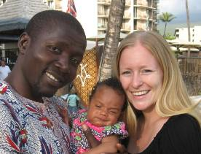
NEWSLETTER DEC 2011 YOUTH WITH A MISSION
FAM NDECHECK MISSIONARIES IN TRAINING
MELE KALIKIMAKA!
(MERRY CHRISTMAS IN HAWAIIAN)

AIM: Starting a Youth With A Mission (YWAM) University of the Nations (UofN) campus in Calabar (Nigeria) where young people are trained to be the key to transform the nations of West-Africa. Ezekiel 37:1-14

THE VISION
We want to start a UofN campus in Nigeria. Here young people will be equipped with professional skills through education to address health care and education needs in West-Africa. In addition they will be stimulated to develop a personal relationship with God on a daily basis
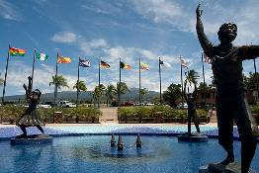
Since April 2010 we are
at the “mothercampus” of
the UofN in Kona, Hawaii
for a planned traningperiod.
At the end of 2011 we would like to look back at the past year with you as well as forward to 2012.

LOOKING BACK ON 2011
The first semester Anneke completed a training in Counseling and Jackson in how to start and equip house fellowships (Acts 2:42-45). These trainings contained a 3 months outreach where we went to Fargo North-Dakota to partner with Impact World Tour.

The second semester Jackson continued with his Bachelor’s program. He followed the Water4Life seminar where he learnt everything about water-purification and collection and he follows a leadership training given by Loren & Darlene amongst others. He also did a Biblical Studies outreach by teaching the Inductive Bible Study approach in 2 different churches and 3 different classes on campus.

Anneke started the second semester as Kona-assistant of Darlene Cunningham, co-founder of YWAM who warmly supports our vision for Nigeria. Through her I have been brought in contact with local and international leaders of YWAM and I’m learning more about the processes within the organization. It is a great privilege to work with her and I enjoy it very much.

In the course of the year we have been able to start the Advisory Board of the UofN Calabar. It is a group of great people from diverse backgrounds: management, technical, agricultural and medical.

HIGHLIGHTS 2011
The “Highest Light” of 2011 is of course the birth of our daughter Hope Shekinah Ndecheck on October 4th 2011.

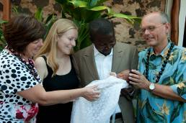
Our Hope got lots of special
attention early on in life as
grandma travelled all the way
from Holland to attend her
birth. Grandpa came two weeks later. Apart from this being a great time of fellowship it was also a tremendous blessing for the help needed post-partum. At the same time my parents could attend the dedication of Hope Shekinah.

In December our dear friends Mark & Lois Bonasera came over from the mainland. Together we celebrated Hope’s first Dutch “Sinterklaas” and we visited a typical Hawaiian “Lu’au”.
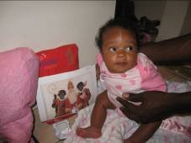
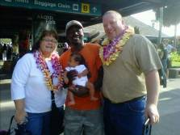
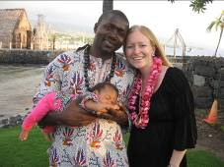

For all your questions contact our homefront at: thuisfrontja@gmail.com
We also have a website with more information: http://www.faith4africa.nl
You can keep in touch with us via facebook or e-mail: ndecheckj@yahoo.com,annekendecheck@gmail.com

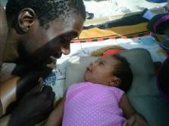
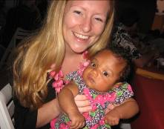
LOOKING FORWARD TO 2012
2012 Jackson will continue his Bachelor and Master’s studies at the UofN. Anneke will continue to be in training as Darlene’s Kona assistant. Hope Shekinah can join both Jackson and Anneke in their work and studies and will therefore not need to go to a daycare.
From April-mid May we will visit Nigeria with a delegation of the recently formed Advisory Board. During this visit we will stay in both Port Harcourt as well as Calabar to strengthen our relationships and look for a suitable place for the campus. At the end of our time in Nigeria we will take Hope to Cameroon to introduce her to her family.
From mid May-June we will be in the Netherlands for 6 weeks. Hope will be introduced to the other side of her family there. We would also like to use that time to give personal updates on the developments of the vision for the UofN Calabar.

PLANNING 2012-2014
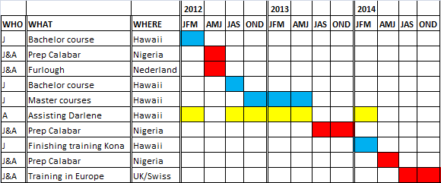
In the next three years we hope to finish our training period in Kona as well as follow a shorter training period in Europe. In order to make a smooth transition we want to take an outreach team of YWAMers to Nigeria each year. For the local population this means aid through short-term medical and water-purification projects. For the students this will be a time to see what working at the UofN Calabar would look like in order to consider joining us for the longer term.

FINANCIAL OVERVIEW
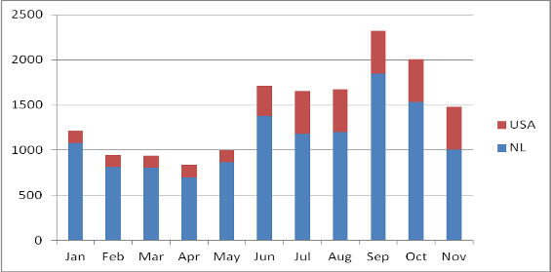
Because we do not receive salary we are financially complete dependent upon support. We have seen God’s provision especially during the birth of our daughter. We were able to buy everything for her that we needed and we received clothing and other gifts in abundance. We want to thank you warmly for all your support, gifts and encouragements the past year!
To make our budget we needed 2500 dollars monthly.
The table shows our monthly support from the
Netherlands as well as the US. In the past year we have
always seen God meet our budget through special
offerings (read more about this in the “testimonies” on
our website).

With the birth of Hope and the planned trip our budget has increased to 3000 dollars per month in 2012. Will you keep us in your prayers?
Giften kunt u overmaken op: giro 5575044 tnv Koinonia-FNDS KvdN Vlaardingen ovv "Jackson&Anneke"
Alle giften zijn aftrekbaar voor de belasting

Voor al uw vragen kunt u contact opnemen met ons thuisfront via: thuisfrontja@gmail.com
We hebben ook een site met meer informatie! Zie: http://www.faith4africa.nl
NEW!!! SUPPORT US WITH TAX DEDUCTION FOR US CITIZENS!!
Make the check out to "UNKF"
Do not put our name on the check, but attach a sticky note with: "#5716/Klugkist"
Mail the check to: UNKF, 75-5851 Kuakini Hwy #256, Kailua Kona, HI 96740.

