

NEWSLETTER OCT 2011 YOUTH WITH A MISSION
SPECIAL EDITION:
HOPE SHEKINAH NDECHECK

Hope Shekinah Ndecheck, born Tuesday October 4th 2011 at 8:24pm.
She weighs 6lbs 2.4 oz and is 18 ½ inches tall

THE BIRTH
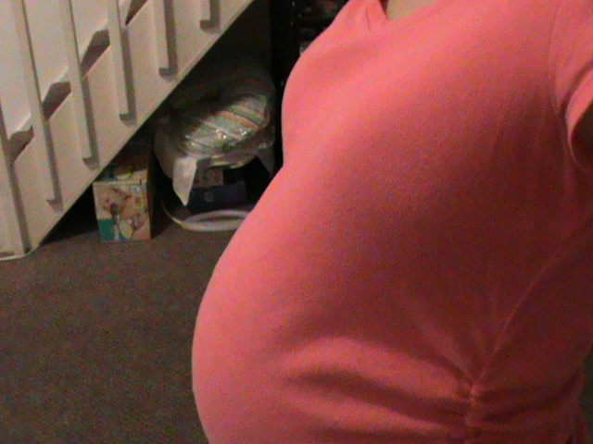
Monday October 3d my water broke, but the contractions didn’t start
Yet.

We called the hospital, who
recommended that we should come immediately.
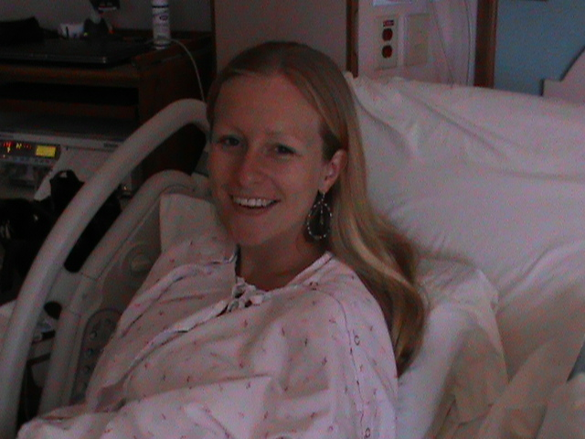
Then it was
waiting time.....

There were some small
contractions, but 24 hours later there was still no progression to active labor.

So we decided to watch a movie...
(Soul Surfer→ very good movie!!)

At 5pm the “real” contractions started, and not so sparingly; 1 minute apart, sometimes 15 seconds, it was incredibely intense, I will spare you the details.

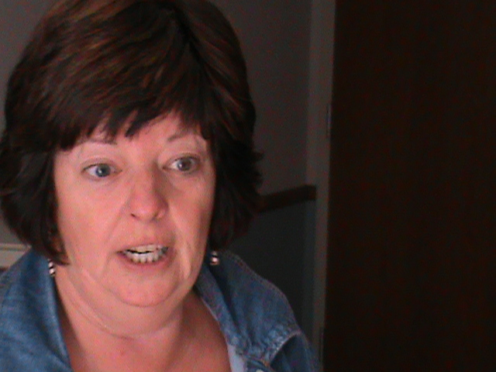
Jackson and my mother
were a great support through
this process.


The midwife was in the room just in time to coach me through the last phase and within a total of 3,5 hours our
daughter “Hope
Shekinah Ndecheck” was lying on my stomach.

Of course a proud father, tired but satisfied mother and a very happy grandma.
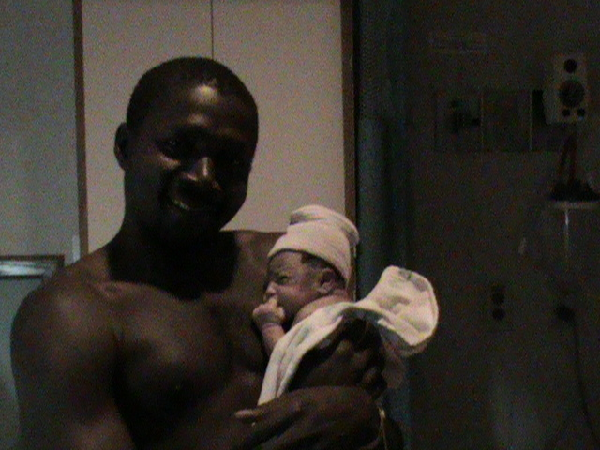



CAMEROON/DUTCH TRADITION
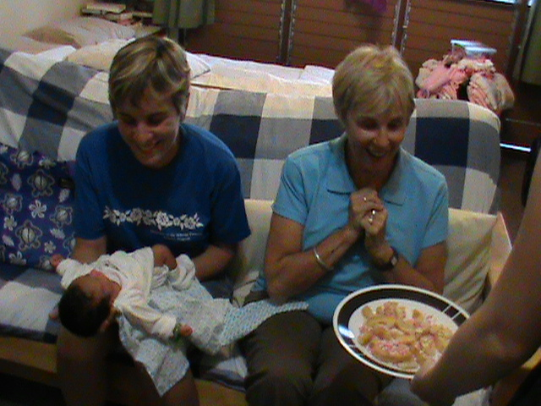
Our visitors are enjoying
Dutch “beschuit met
muisjes” as well as a Cameroon
”baby powder shower”.

HOPE SHEKINAH NDECHECK


Our daughter is very healthy,
very enthusiastic about
breastfeeding and she sleeps well.
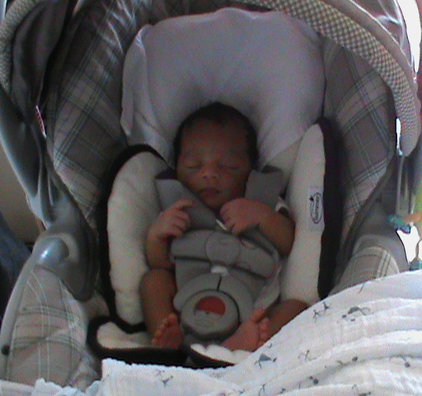
Challenge is that she prefers
to sleep long hours during the
day and short hours during the
night. According to grandma her body has adjusted to the Cameroon/Dutch timezone.

Her name “Shekinah” originates from the Hebrew language and means: “abiding presence”. It is found in the Bible where the glory of the Lord fills the tabernacle to abide with the people (Exodus 40:35).
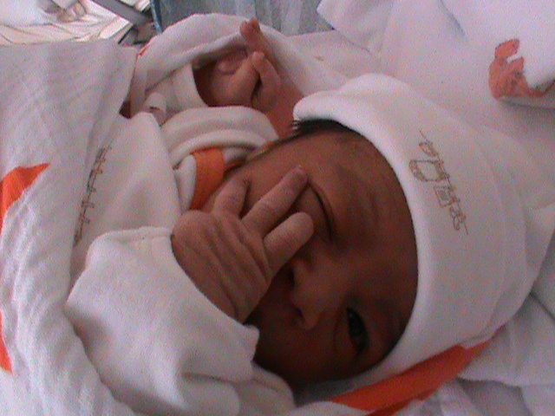
Her name “Hope Shekinah”
Reminds us of the hope we
have in His abiding presence.

MATERNITY LEAVE
I have entered a time of rest and being spoilt by my mother who came to Hawaii especially for this occassion. My father is soon coming to visit also to meet his granddaughter. Jackson is continuing his studies as well as the care for his “two ladies”.

PRAYER POINTS
We thank God for the speedy delivery as well as such a beautiful healthy daughter.

Jackson Ambe Ndecheck, UofN, 75-5851 Kuakini Hwy #381, Kailua- Kona, HI 96740, USA
For wire transfers: Central Pacific Bank, Acct Name: Jackson Ambe Ndecheck, Acct Nr: 6001563488,
Routing nr: 121301578

